**Sprint 2 Reflection**

Hunter Figgs

Jared Perkins

Sergei Fedulov

Patrick Haughn

Jeffrey Gaydos

CSE 3902, Professor Boggus

5 October, 2020

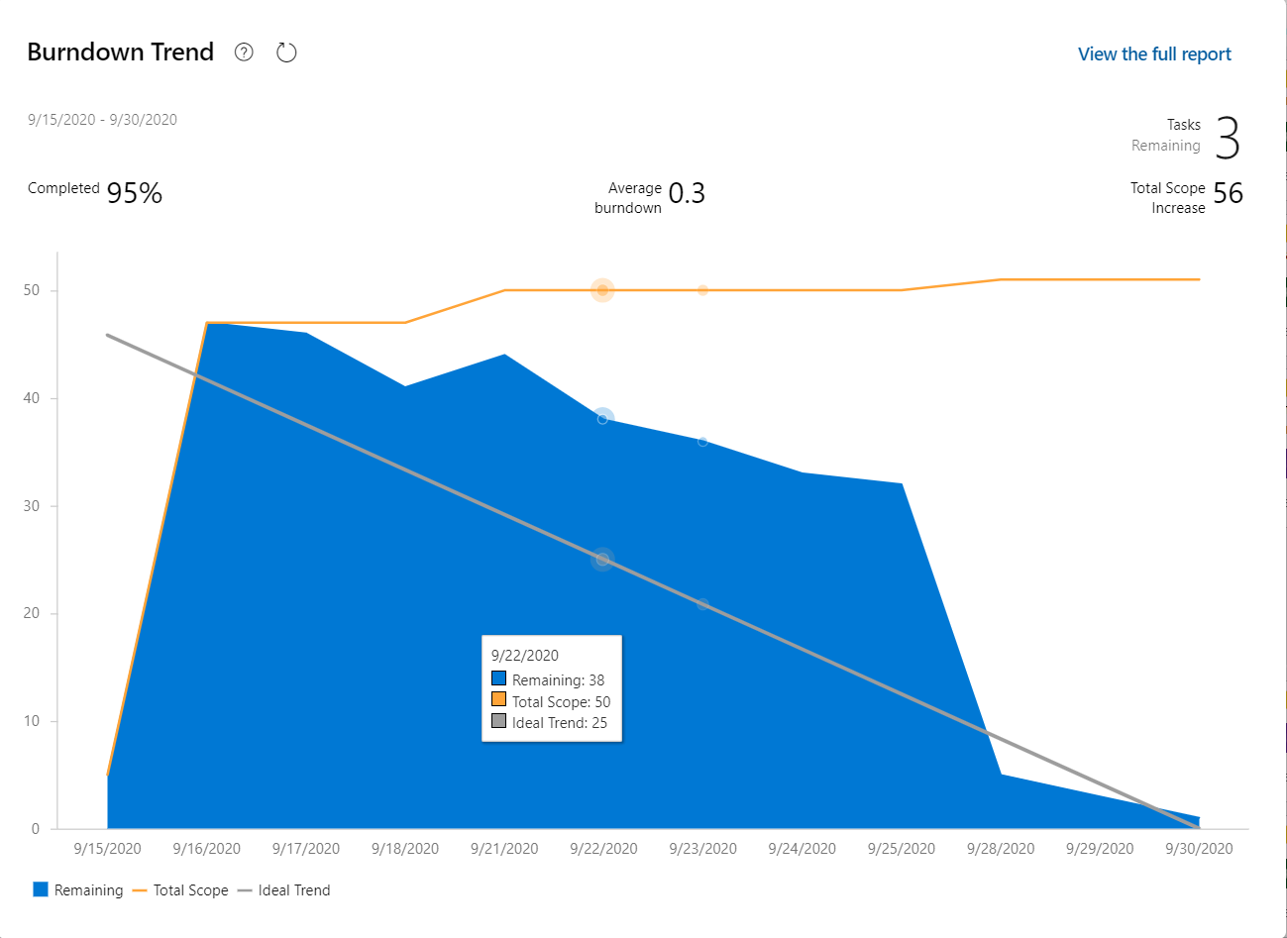

Viewing the Burndown Trend, the group as whole appeared to complete more work towards the end of this sprint. However, this is likely due to how large our original assigned tasks were. Each member was assigned to a set of objects grouped by interfaces (IEnemy, IEnvironment, etc.), but later on in the project, smaller tasks were added to polish and fix any bugs in the project. Additionally, in the beginning of this sprint there was a lack of uniformity in how objects got sprites, and some members made equally valid, but differing systems, resulting in repeated functionality in the project. Another issue was the lack of uniformity in the interfaces. This caused maintainability issues since some interface methods had different parameters. The team plans to write agreed upon interfaces (or other “base” code) in a preliminary meeting at the start of the next sprint.

The processes used during this sprint were effective and ensured that the project was done correctly. An initial meeting was scheduled to assign tasks and discuss overall functionality. Subsequent Wednesday meetings were used to help any members who were struggling, decide on further functionality, and clean up any bugs in the project. These subsequent meetings helped to ensure that the objects each team member made had collision mechanics in mind. However, the team could benefit with more short meetings to not only clarify task assignment but also inform others of what is currently being worked on and how members can best use each other’s code to their own benefit.

The team completed this sprint with all required functionality as well as some extra features such as the beginnings of collision mechanics found in some enemy behavior as well as some item behavior. Also, a package was added and utilized in the project which will help make resolution scaling more easy. This package allows the team to develop to a “Virtual” resolution and let the package do the rest. The team believes that the current objects are on track to have collision mechanics in the next sprint.